Notes | 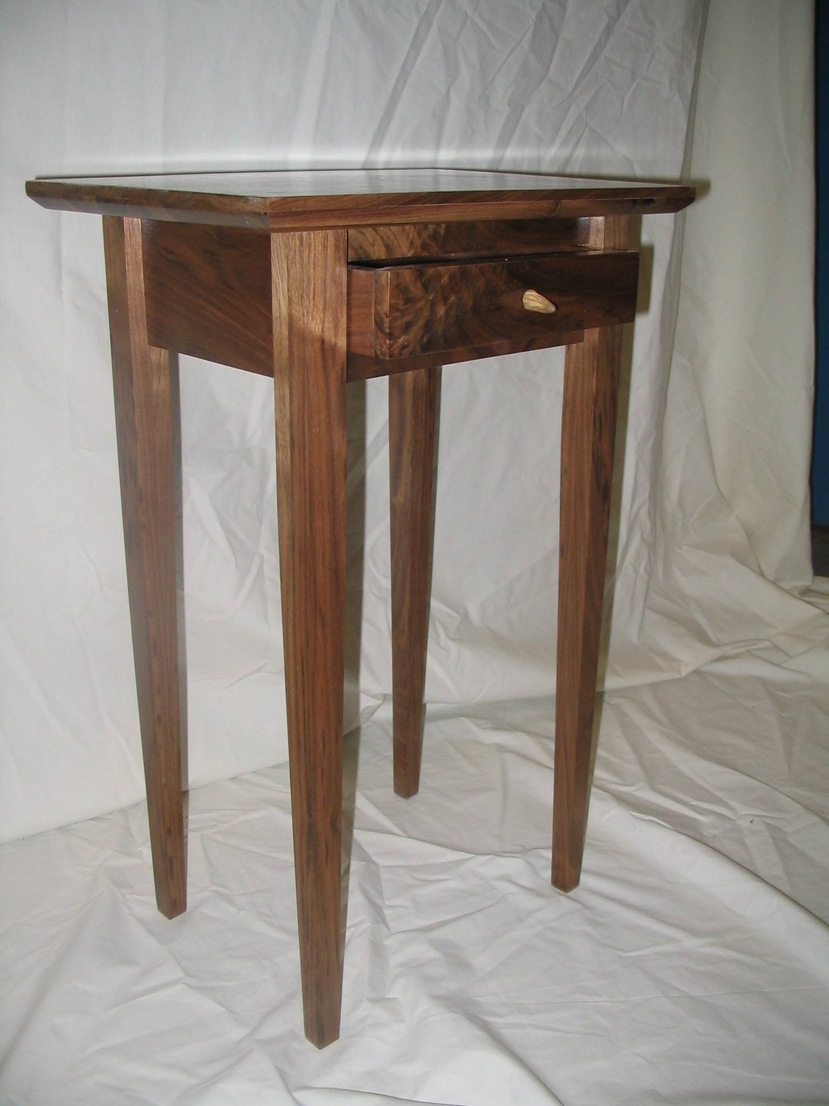 | Notes

Part | Size |  |  | Number of Pieces | Material
Part | t” | w” | l” | Number of Pieces | Material
Top | ¾” | 12 | 15 | 1 | Good Wood
Legs | 1 ¼” | 1 ¼” | 23 ¼” | 4 | Good Wood
Back Rails | ¾” | 3 ¾” | 10 ½” | 1 | Good Wood
Drawer Rails | ¾ | 4” | 10 ½” | 1 | Good Wood
Short Rails | ¾ | 3 ¾” | 7 ½” | 2 | Good Wood

Machining Notes
Drawer front is cut from the drawer rail 7/8” from each edge. Trim off the tenons using the compound miter saw to make it fit in the assembled table.
Grooves - Cut the groove for the table top clips ½” from the top edge and 3/8” deep on all rails
Cut the groove for the drawer bottom ¼” from each edge of the drawer box including the front.
Tenons - Cut tenons on both ends of all table rails. The tenons are ¼” thick and ½” long. The shoulder cut is also ¼” for each tenon. There is a 45 degree angle cut on the end of the tenon on each drawer rail
Mortises - Cut mortises ¼” from each inside edge of each leg. See detail for exact measurements. Use a try square or combination square to lay out the legs.
Bevel - A 45-degree x 3/8” long chamfer is cut on the bottom edge and all sides of the tabletop using a table saw.
Tapers - After you cut all of your mortises, use the taper cutting jig and a table saw to machine the tapers. Your tapers are cut on the same sides as your mortises. During the cut the mortise must always face the blade.
Rabbets - Cut ¼” deep x ½” wide rabbets on the ends of the drawer front and back using a table saw and stack dado cutter.
Legs Top
Machine | Steps | Machine | Steps

Rails Drawer
Machine | Steps | Machine | Steps

Sketch of Drawer Box
Top View and Isometric

Parts List
Part Name | t” | w” | l” | Material
Drawer Front | ¾”
Drawer Back | ½”
Drawer Sides | ½”
Drawer Bottom | ¼”
Top Slides | ¼” | ¾”
Bottom Slides | ¼” | ¾”

Detail Sketches
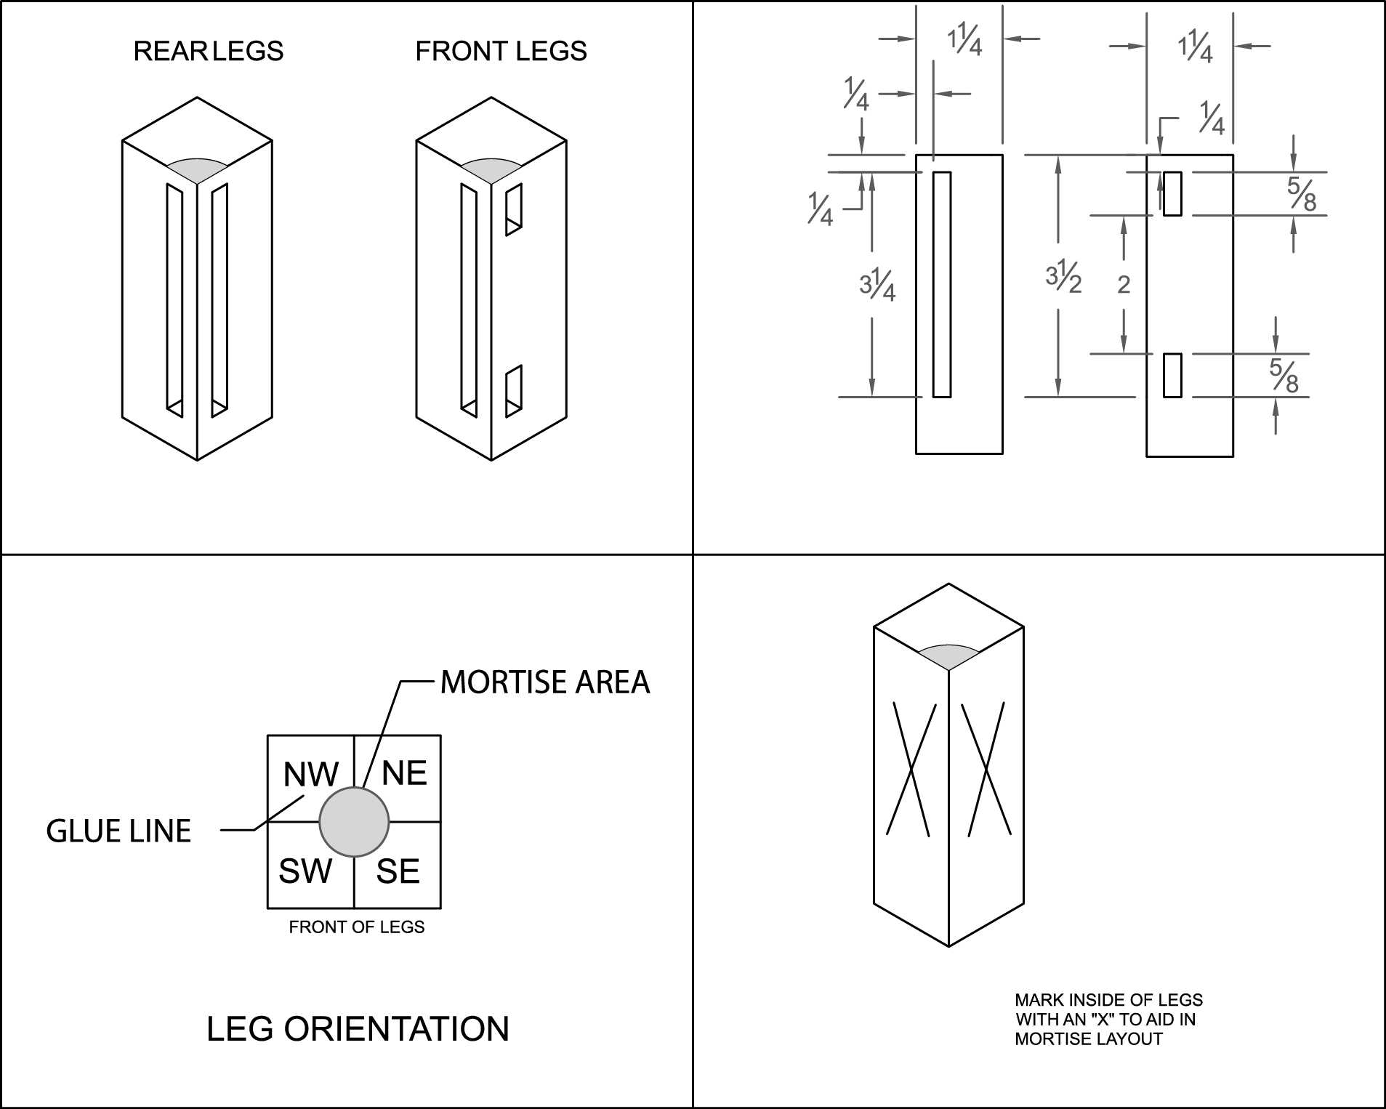

Problem Solving Notes

